PROJECT REPORT

**PROJECTTITLE:** OPTAMIZING USER,GROUP AND ROLE MANAGEMENT WITH ACCESS CONTROL AND WORFLOWS

**TEAM ID:** NM2025TMID18793

**TEAM LEADER:** VIGNESH B

**TEAM MEMBER**: KISHORE T

**TEAM MEMBER: TAMIL J**

**TEAM MEMBER:**CHANDARA SEKAR J

**DEPARTMENT:** COMPUTER SCIENCE

**COLLEGE NAME:** L.N GOVERNMENT COLLEGE

**YEAR:** 3RD YEAR

**CONTENTS**

1. **INTRODUCTION**
2. **PROJECT OVERVIEW**
3. **OBJECTIVES**
4. **IMPLEMENTATION**
5. **CONCLUSION & LEARNINGS**
6. **Introduction**

In a project team consisting of a Project Manager (Alice) and a Team Member (Bob), the absence of clearly defined roles and structured workflows created confusion in task ownership and accountability. The goal of this project was to implement a system using ServiceNow that enables proper user, group, and role management, along with secure access control and automated workflows. The solution aimed to promote collaboration, streamline operations, and improve task tracking throughout the project lifecycle.

1. **Project Overview**

Efficient user, group, and role management is critical for maintaining security, compliance, and operational efficiency within any enterprise IT environment. In ServiceNow, the effective use of access controls and workflows plays a pivotal role in ensuring that users have appropriate access to resources while minimizing risks and administrative overhead.

This project focuses on optimizing the processes involved in managing users, groups, and roles within the ServiceNow platform. By leveraging automated workflows and robust access control mechanisms, the goal is to streamline identity lifecycle management, enforce the principle of least privilege, and enhance auditability.

* 1. **Stakeholders Assigning Roles to users:**

|  |  |
| --- | --- |
| **Alice** | Project Manager |
| **Bob** | Team Member |

**Roles & Responsibilities:**

|  |  |
| --- | --- |
| **Project Manager** | Define and assign project tasks to team members. Approve task completions and progress updates |

|  |  |
| --- | --- |
| **Team Member** | Update the task status (e.g., In Progress, Completed) as work progress, submit completed tasks for approval and automate the workflow. |

1. **Objectives**

* Implement structured role and group management.
* Define secure access controls using ServiceNow ACLs.
* Create custom tables for project-related data (e.g., tasks, deadlines).
* Automate project workflows using ServiceNow Flow Designer.
* Improve communication and accountability within the team.

Through this initiative, the organization aims to not only improve the accuracy and efficiency of user access provisioning but also to strengthen its overall security posture and enable scalable governance across the ServiceNow environment.

1. **Implementation**

* **Created Users and Roles:** Represented Alice and Bob with different access levels.
* **User-Group Assignments:** Linked users to groups based on responsibilities.
* **Created Tables:** Defined tables for tracking tasks, statuses, and project updates.
* **Access Controls:** Configured ACLs to restrict or allow access at table and field levels.
* **Workflow Automation:**
  + Used Flow Designer to automate task assignments and status updates.
  + Designed approval processes to notify the Project Manager upon task completion.

1. **Conclusion & Learnings**

This project demonstrated the impact of structured access management and workflow automation in a collaborative environment. With clearly defined roles and secure data access, Alice and Bob were able to manage tasks efficiently.

The use of ServiceNow tables facilitated better project tracking, while automated workflows reduced manual effort.

Key learnings include:

* Effective use of ServiceNow modules for user and role management
* Building secure, scalable ACLs
* Automating repetitive processes with Flow Designer

Translating real-world

Optimizing User, Group, and Role Management with

Access Control and Workflows

1. **Creating User**

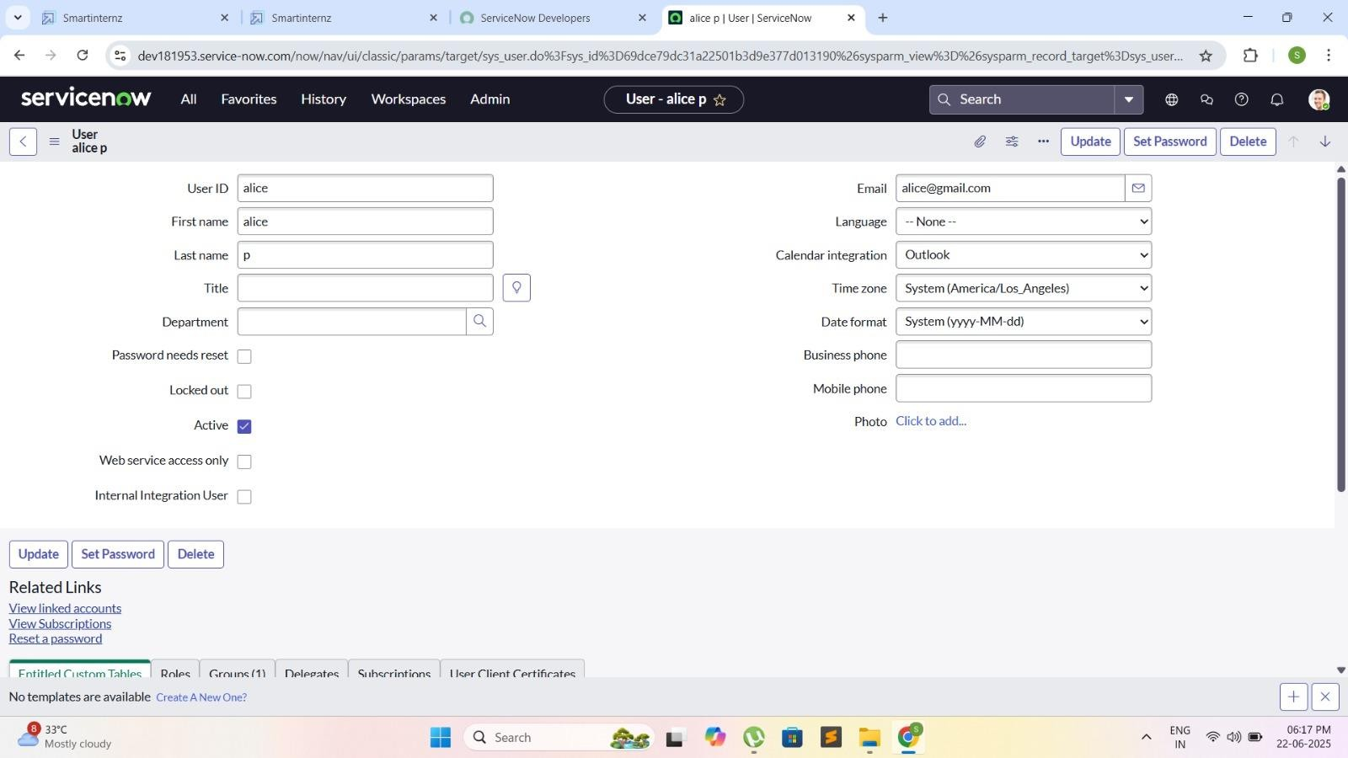**Alice p:**

* + **Bob User :**

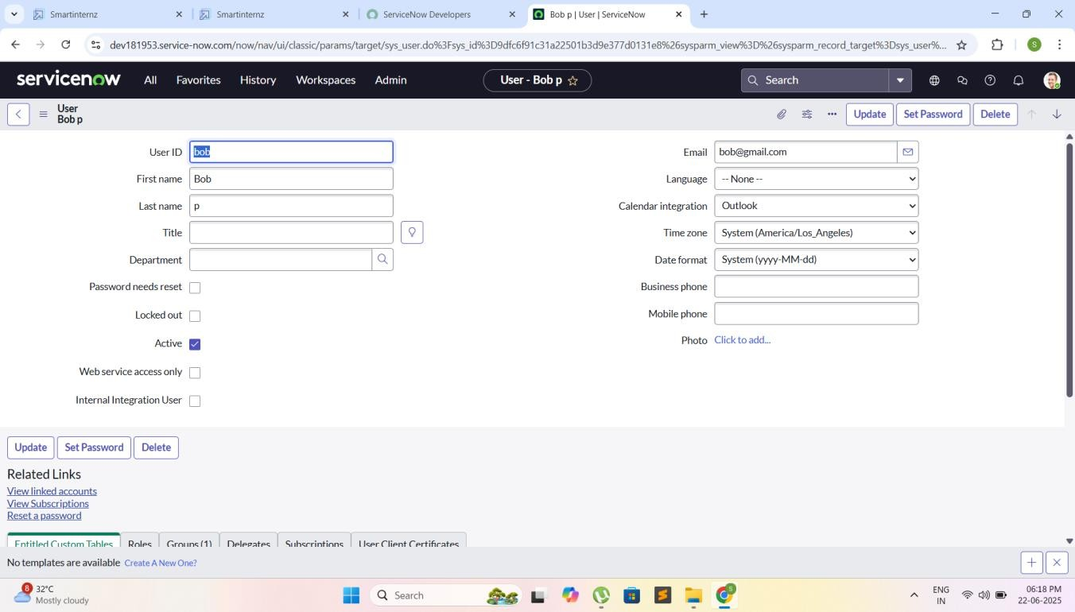

1. **Creating Groups:**

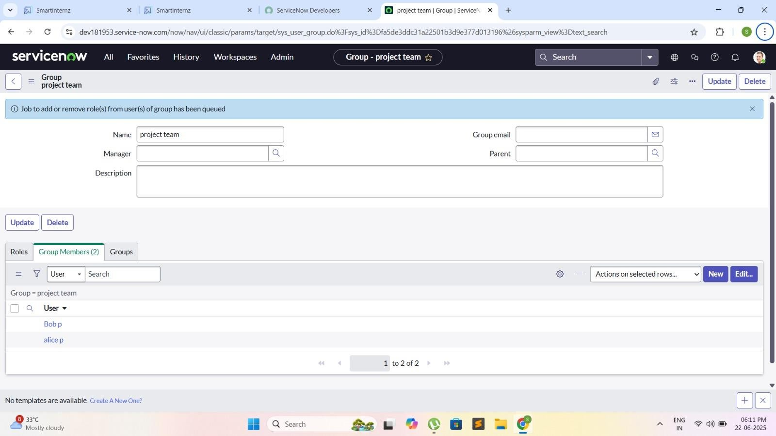

1. **Creating Roles**

**Project member:**

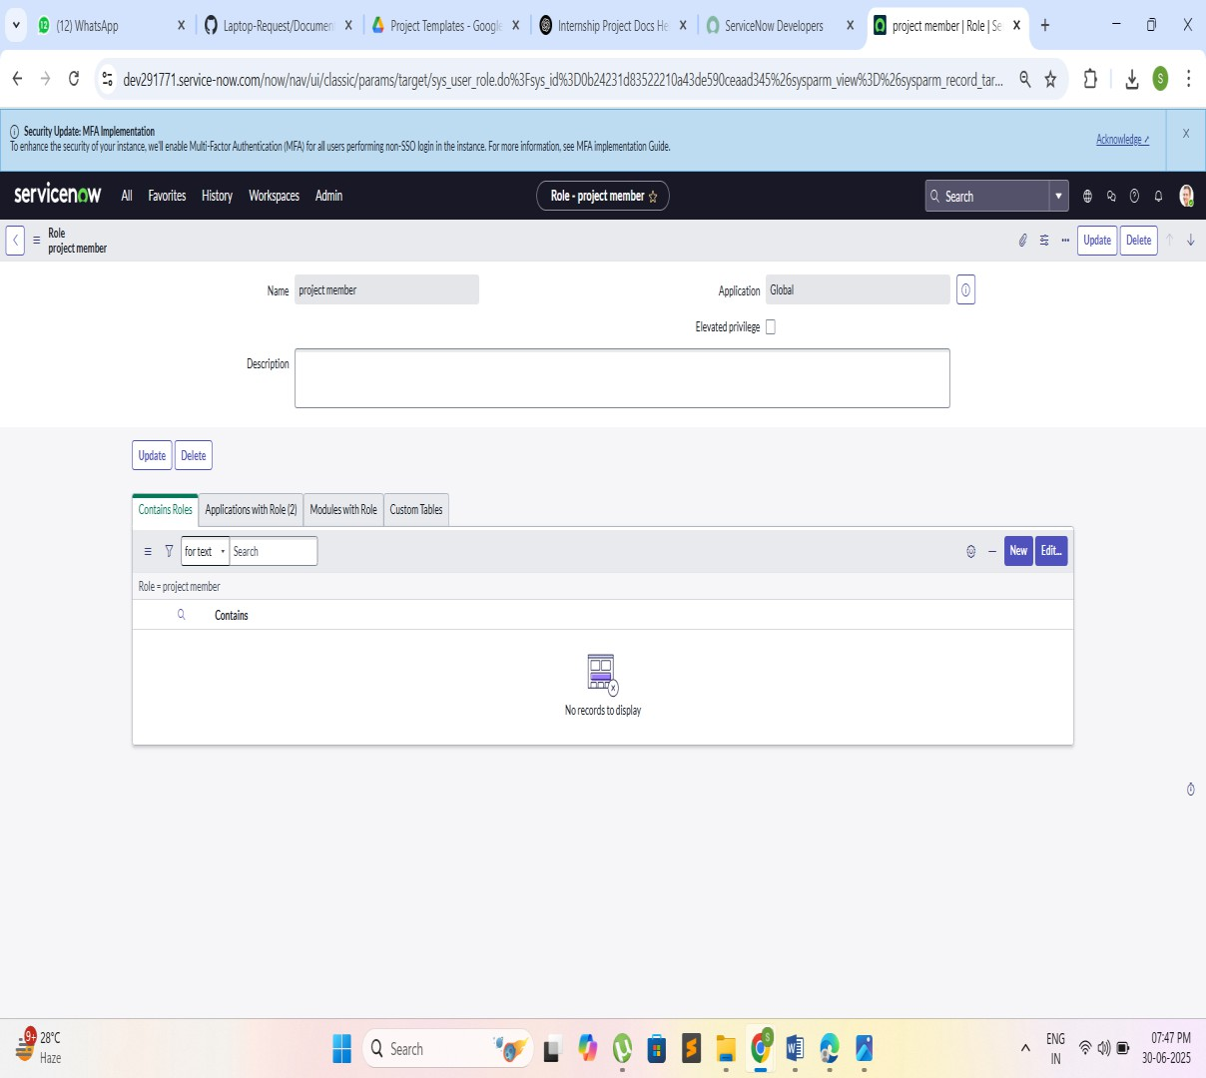

* + **Creating one more role**

**Team member:**

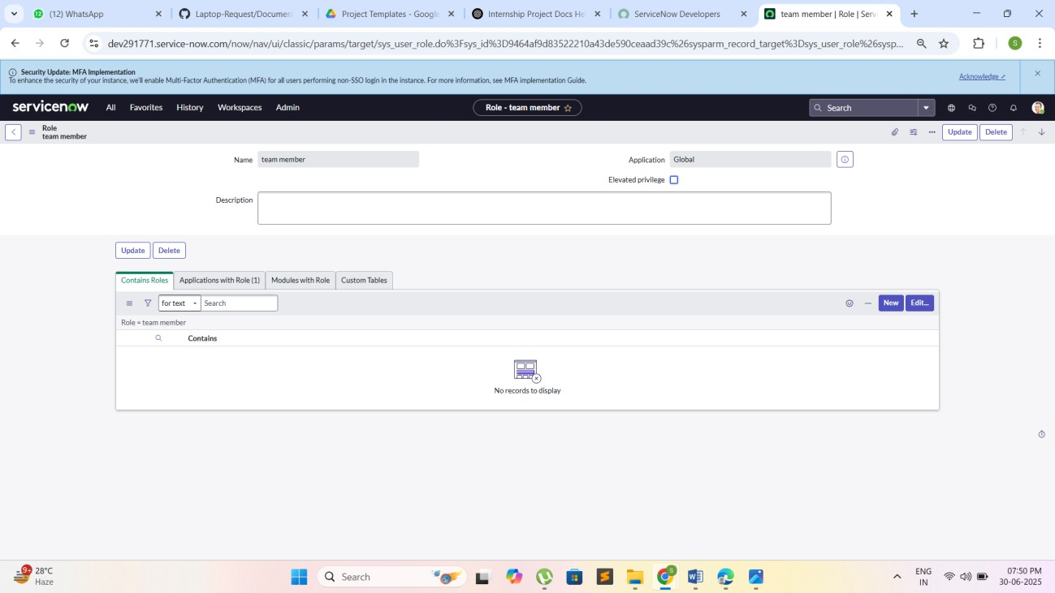

1. **Creating tables**
   * **Project table:**

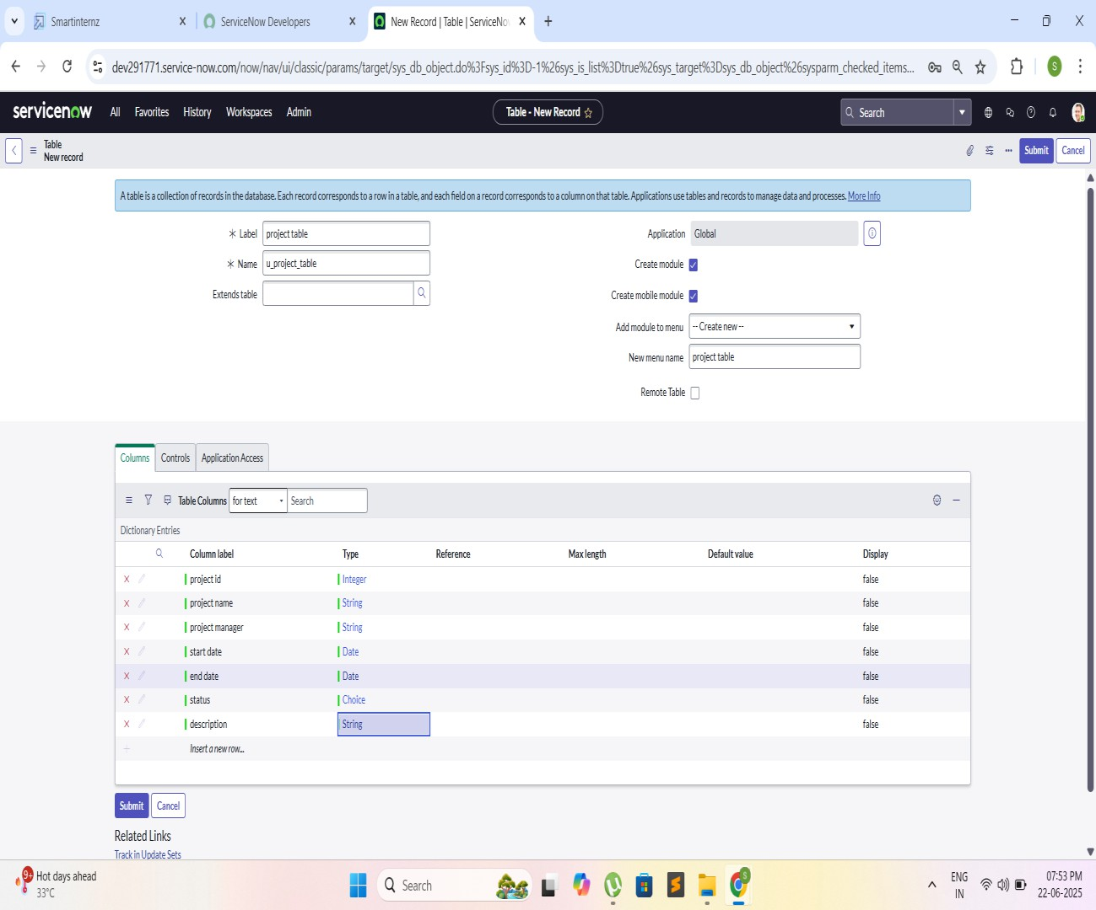

* + **Task table2:**

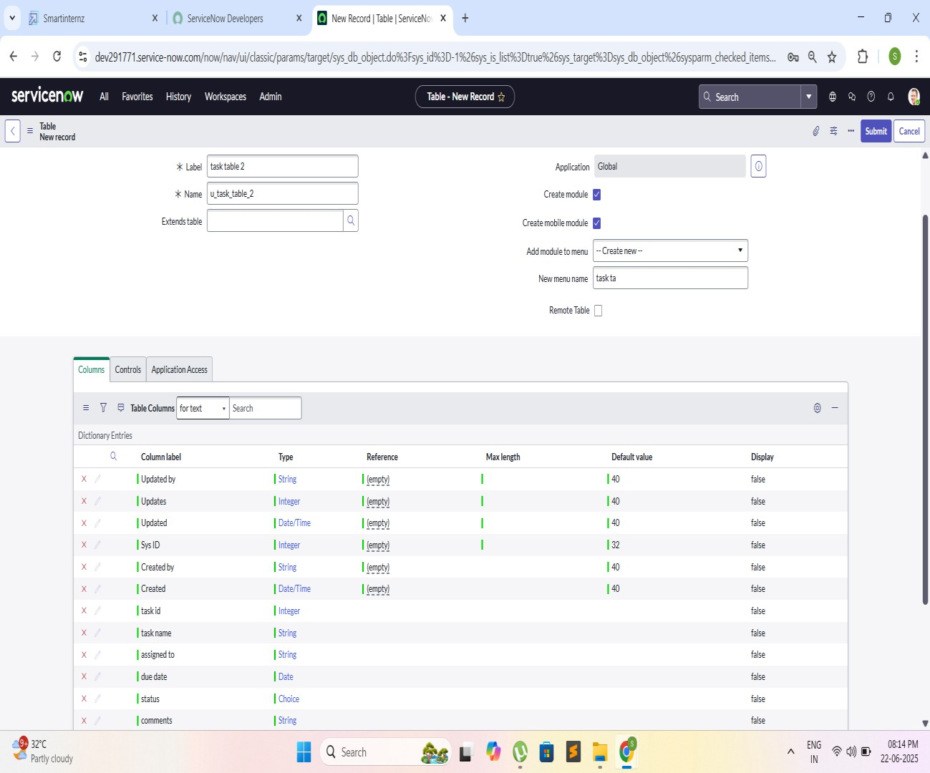

1. **Assigning Users**
   * **Project Team Group:**

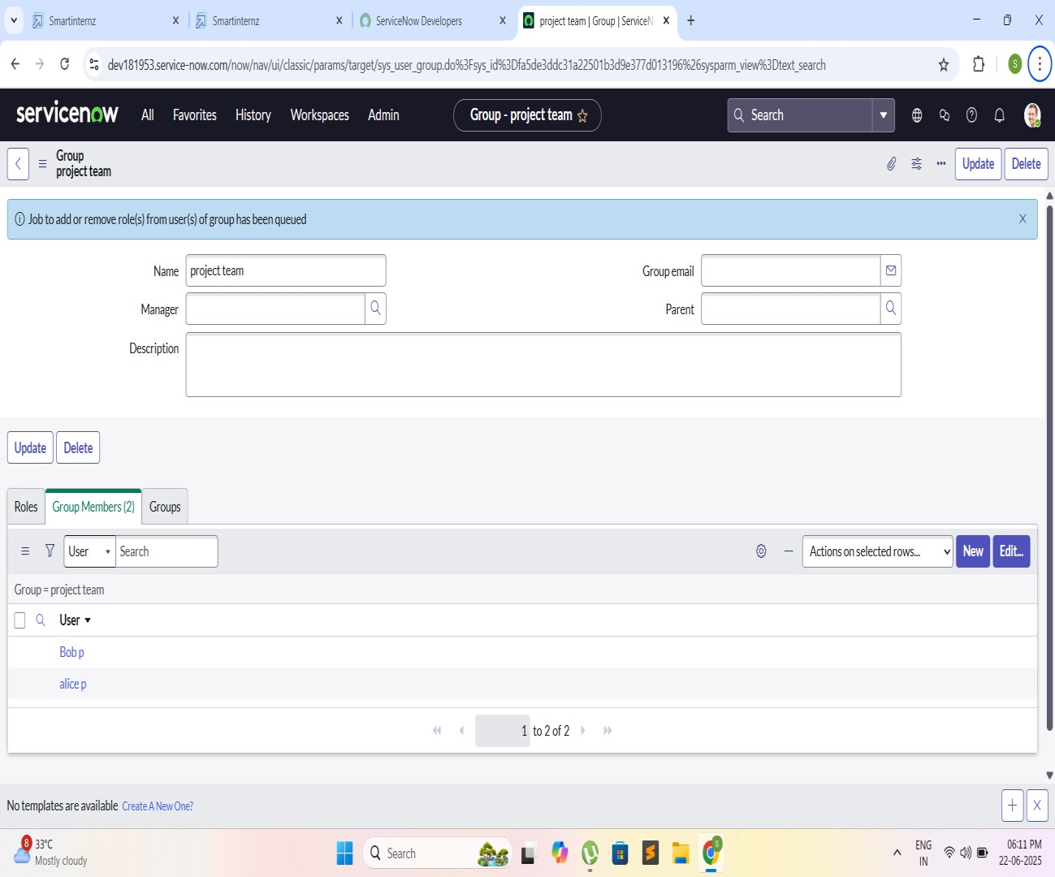

1. **Assigning Roles to Users**
   * **Alice:**

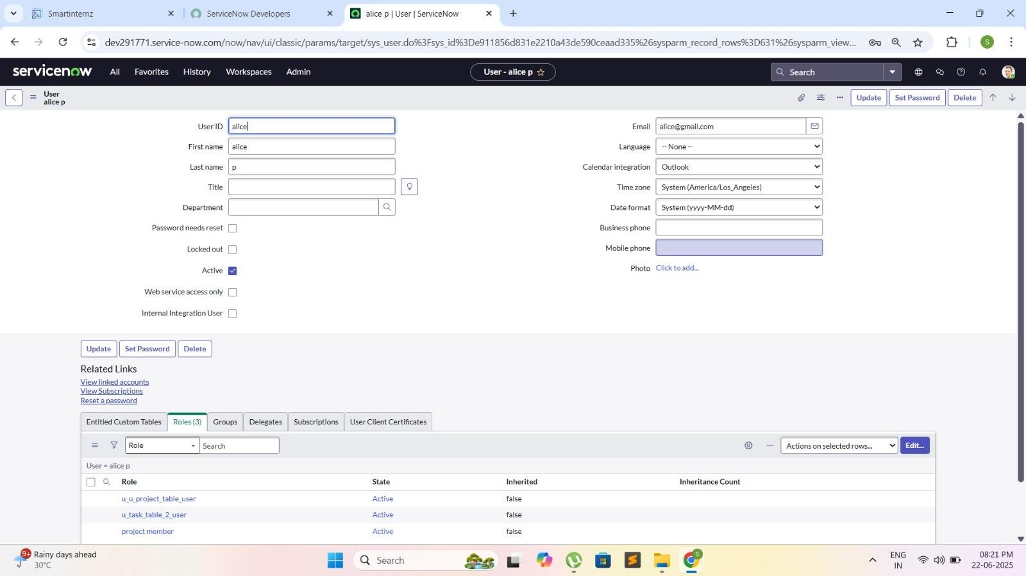

* + **Bob User:**

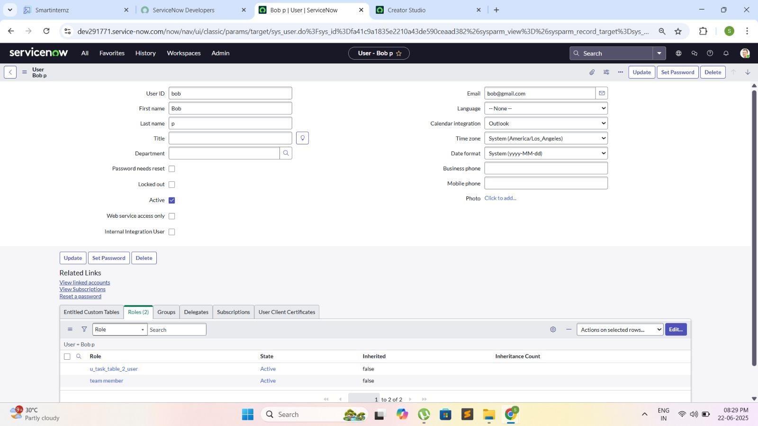

1. **Assigning Table Access to Application**
   * **Project table:**

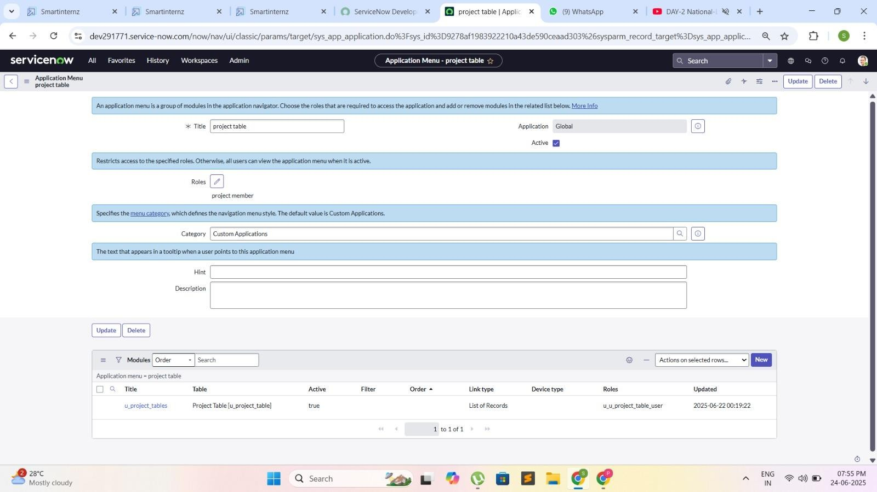

* + **Task table 2:**

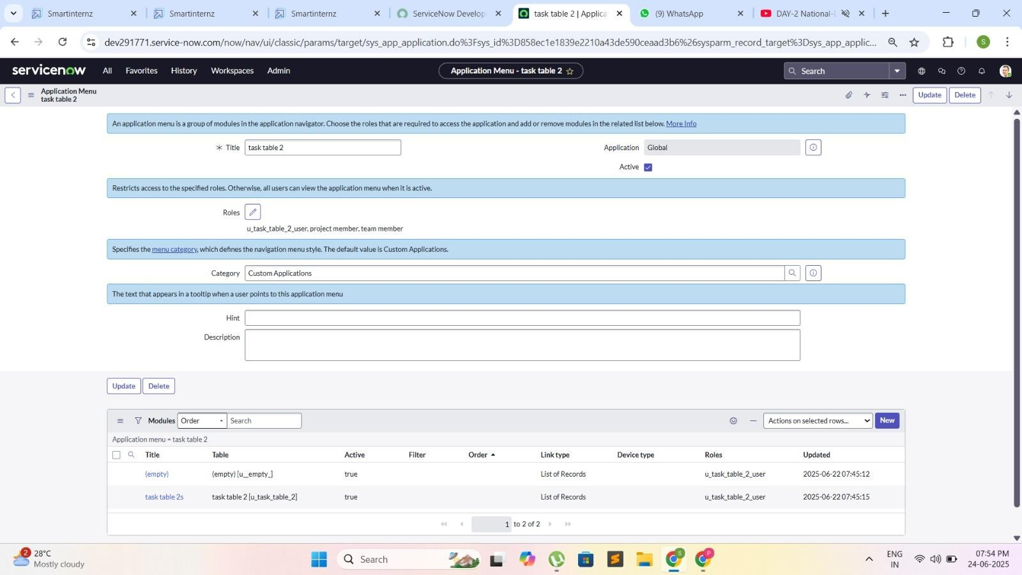

1. **Access Control List**
   * **Creating ACL:**

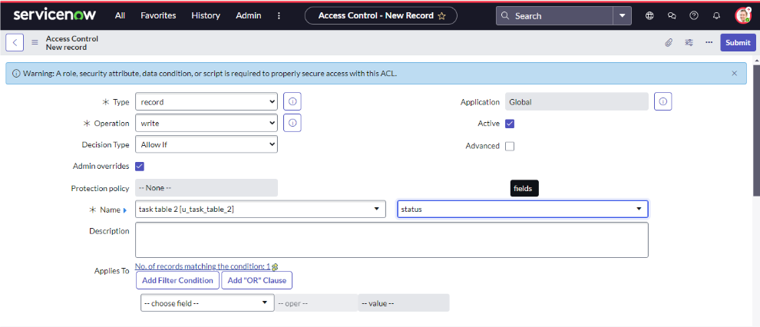

* + **Assiging ACL Bob user :**

**Task table 2:**

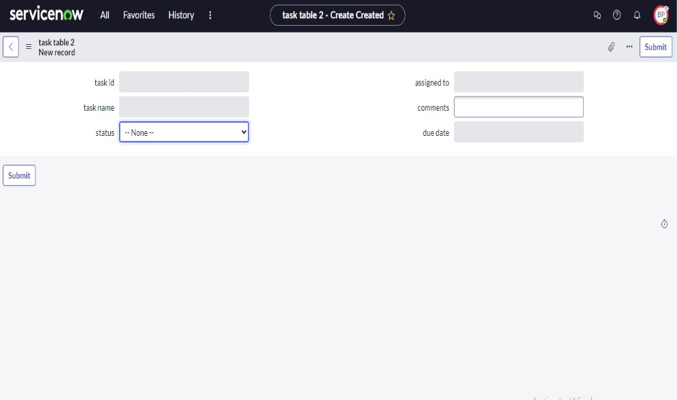

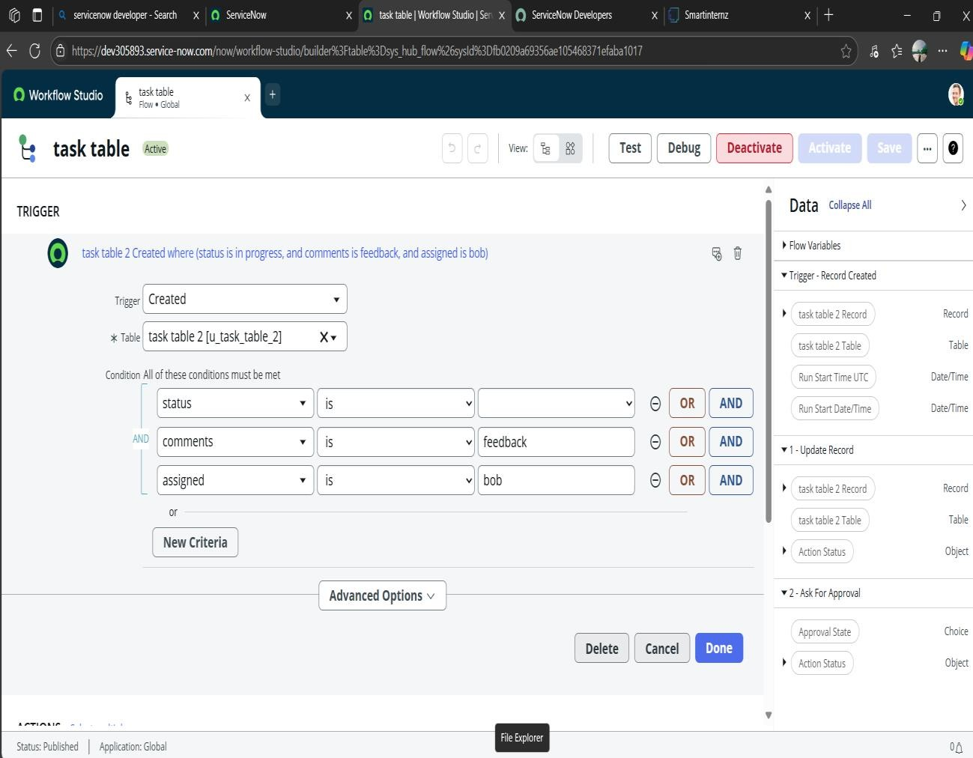

* + **Adding an Action:**

